Speaker Presentation Application
Mental Health KC Conference Friday, May 1, 2020
8:30 AM – 4:00 PM
Cerner Innovation Campus
8779 Hillcrest Rd, Kansas City, MO 64138

DUE January 1, 2020

www.mentalhealthkc.org

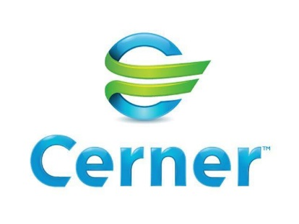
Sponsored by:

Presentation Proposal Overview

Coordinated by the Metro Council and hosted by Cerner, this year’s Mental Health Awareness Conference theme is “Wellness”. The purpose of this event is to offer community education and to create awareness about mental health in our community. In recent years, we have noticed a specific need for education surrounding wellness, mental health in the workplace and suicide awareness and prevention. This conference will continue to be targeted toward Human Resources Professionals, Corporate Employers/Employees, Community Health Leaders, Practitioners, and Health and Social Services Providers that live and/or work around the Kansas City area. As efforts are increased to educate our community, we are seeking professionals that are willing to contribute to this event by speaking on behavioral health and wellness.

This application serves to identify dynamic, knowledgeable speakers and topic facilitators for the 2020 conference. This conference seeks to offer a diverse track of speakers to lead breakout sessions that cover a wide range of topics around behavioral health. Attendees will receive current industry leading, best practice approaches to affect change in their life and in the lives of others. The conference will consist of a Keynote Speaker to start the day followed by breakout sessions.

Our Keynote Speaker will be Bowen F. White, M.D. and he will be speaking on the topic of “Why Normal Isn’t Healthy.” Dr. Bowen White is the author of Why Normal Isn’t Healthy. Besides appearing on the front page of the Wall St. Journal and on national television programs such as CBS This Morning, Desmond Morris’ The Human Animal and the PBS series The Promise of Play, Dr. Bowen White is often interviewed by radio, newspaper and magazine journalists. He has eight years of experience as a weekly TV health commentator for Kansas City’s CBS-TV affiliate and also had a three year stint writing a weekly newspaper column, entitled Patient Potential, for the Kansas City Business Journal.

Details regarding the breakout sessions are provided below:

- Length of Session: Varied (See attached application)
- Average Number of Attendees per session: 50
- Computer/AV Equipment Provided

Presenter Contact Information
First name:______________________ Last Name:_________________________________
Title:__________________________________________________________________________
Organization:___________________________________________________________________
Email:________________________________________________________________________
Address:________________________ City:______________________________________
State:____________________ Zip:____________ Cell phone:_____________________

Presenter Biography (150 Word Max):

Presenter Headshot: If selected as a presenter, you will be asked to submit a headshot to be used on the event website and other media platforms.

Do you CONSENT for the Mental Health KC event organizers to use your photo in this manner?
_____Yes _____No

Have you presented on this topic before: _____Yes _____No

If yes, please answer the following questions below.

For Whom?___________________________________________________________________

Where?____________________________ When?____________________________________

Presentation Proposal

Presentation Title:

Preferred Presentation Length (please check all that apply):
- 60 minutes
- 90 minutes
- 120 minutes

Presentation Abstract (250 Words Max – Attach Separate Sheet If Necessary):

Learning Objectives:

#1:

#2:

#3:

Three keywords that best describe the focus of your presentation:

#1:

#2:

#3:
Speaker Disclosure Statement
I have no conflict of interest with the Metro Council regarding my presentation or presenting at this conference. I understand that my learning session is not a showcase for promotion of my business, practice, or product. I acknowledge that Metro Council has the rights to utilize the information in marketing the breakout sessions if I am selected to be a presenter. If selected to present at the Mental Health KC Conference, I will supply a copy of the Power Point presentation to Metro Council along with a professional photo (jpg, pdf) within 30 DAYS of notification.
I hereby acknowledge the above statement:

___________________________________________ ________________
Signature Date

Questions
If you have questions about this application or the event please contact Jenna Harper, Truman Medical Centers – Behavioral Health via email at jenna.harper@tmcmed.org.

